A Review on Cloud Enabled AI Framework for Optimizing the Software Development Life Cycle

ABSTRACT
The Software Development Life Cycle conducts its operations through the ordered phases of Requirement analysis followed by design and implementation then testing followed by deployment and maintenance which together produce high quality software. Traditional SDLC models including Waterfall, Agile, Spiral, and DevOps follow structured approaches with varying levels of adaptability. Manual task coordination in these models results in operational inefficiencies which drives up project expenses and increases the probability of project termination or project delays.
This research presents an AI-powered SDLC framework which utilizes transformer-based Large Language Models (LLMs) through GPT-J together with generative AI to automate every SDLC phase through intelligent agents which perform requirement extraction and design blueprint creation and code review and test case generation. The model provides smart task scheduling and risk assessment features while its cloud integration enables both scalability and flexibility and immediate access to real-time data.
An AI-optimized SDLC system delivers substantial improvements in development speed and risk management capability while ensuring software processes match current business goals which represents a modern approach to software engineering.
KEYWORDS
AI in SDLC, Cloud Computing, Transformer Models, Resource Optimization, Natural Language Processing, Project Management, SDLC Optimization.
I. INTRODUCTION
Providing orientation through systematic phases of software development for quality and in line with organizational objectives is the main focus of the Software Development Life Cycle (SDLC). As time has passed, it has become evident that traditional approaches started facing problems with ambiguity, inefficient use of resources, and ever-increasing complexity of systems. Given such issues, researchers have been investigating methods that put automation techniques in the forefront of intelligent modelling. Alksasbeh et al. [1], for example, presented a method for automating the generation of UML use case diagrams from natural language requirements, thereby diminishing errors that could occur in manual interpretation and enhancing the clarity of requirements. Likewise, Harzevili and Alizadeh [2] developed a classifier based on a latent multinomial naive Bayes, which contributes to improved decision-making accuracy for classification tasks and hence becomes pertinent to requirement analysis and risk predictions. More recently, Bahi et al. [3] Integrating Generative AI into Agile has been studied to determine if AI could solve certain project management issues and increase agility. Hence, these studies aim to give an overarching view of the transition from largely human-dependent cases into automation and AI-aided SDLC.
Opening the door for AI applications in software engineering, other researchers went on increasing the possibilities. Alenezi and Akour [4] examined AI-enabled improvements in current approaches to software engineering and, while doing so, illuminated new opportunities for their automation and efficiency. Russo [5] in contrast made a case that Generative AI is hard to adopt owing to explainability, ethics, organizational readiness, etc. Jahic and Sami [6] reviewed the state of practice of Large Language Models (LLMs) in software engineering and architecture, presenting evidence that MLLs are playing roles more and more in contextual reasoning and software design. Complementary to this, Mornie et al. [7] proposed an approach for visualizing user stories into UML use case diagrams to ease communication with stakeholders and validate requirements. These contributions tackle the promises and challenges of AI technology integration within the SDLC.
Stretching the landscape further, the works in the recent past have been able to establish that artificial intelligence can affect not only requirements and design but also any life-cycle activity at large. Radler et al. [8] carried out a systematic search across Model-Driven Engineering (MDE) and AI and showed using domain-specific languages combined with intelligent techniques to effect automation of complex engineering tasks. On the same note, Nair and Thushara [9] gave the NL2Code solution, which is a hybrid NLP and MDE-framework for automated code generation from natural language and UML models, this way reducing manual development effort. Ebert et al.'s [10] study gave practitioners insight into working usages of Generative AI to lift their productivity as well as day-to-day engineering tasks, while Kumar [11] discusses the role of Generative AI in software architecture, arguing how generative adaptive methods may be applied to the processes of design and development. Kapoor [12] took it a step further in demonstrating how AI-driven product lifecycle management data insights nurture innovativeness, efficiency, and sustainability in industries.
This study centers on building and implementing an AI-driven framework for SDLC optimization, including automatic requirement analysis, UML diagram generation, automated code generation, testing, and risk management supported by transformer-based and model-driven techniques. The framework integrates cloud-native architectures to maintain scalability and real-time availability. In contrast, hardware-level optimizations, organization-specific customizations, or case studies at the domain level are explicitly left outside the investigation, for they are custom of a very specific nature beyond the general software engineering scenarios embraced in this framework.
The proposed approach is a practical and implementation architecture for requirement extraction, automatic code generation, risk analysis, and project management. This framework reduces human error, shortens project delivery time, and utilizes resources better against others. In the end, the automation of ESG will help in promoting resource efficiency and real-time adaptability, thus contributing to sustainable software engineering.
Section 2 refers to the Background Study, touching on the SDLC basics, its issues, and the opportunities presented by AI, LLMs, and cloud technology. Section 3 sets out the Selection Criteria detailing the considerations made for the papers and studies that were reviewed. Section 4 refers to the Literature Review that gives a summary of existing research and approaches in the field. Section 5 makes up the Analysis and Performance Comparison of approaches, which means their merits and demerits. Section 6 denotes the Research Gap in which the weaknesses of previous works are examined, and serious consideration is given to further development. Section 7 discusses Future Directions wherein worthy improvements may be undertaken in conjunction with this research. Finally, Section 8, titled Conclusions, provides a concluding overview of the study's results and contributions.
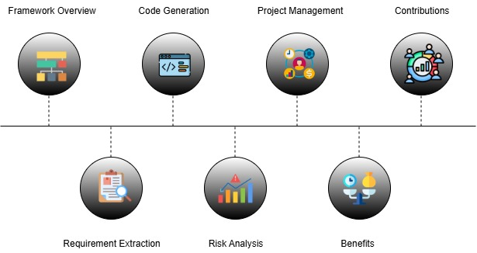
Figure 1: Conceptual Architecture of AI-Driven SDLC Optimization Framework
II. BACKGROUND STUDY
This chapter shows the fundamental concepts of this research. It starts by examining the traditional SDLC and its challenges. And then considers the transformative role of Artificial Intelligence (AI) and Large Language Model (LLM) in these challenges. At the same time, it discusses the cloud infrastructure, which can provide scalability, integration and adaptability for AI-based software development.
2.1 The Traditional Software Development Life Cycle and its Challenges
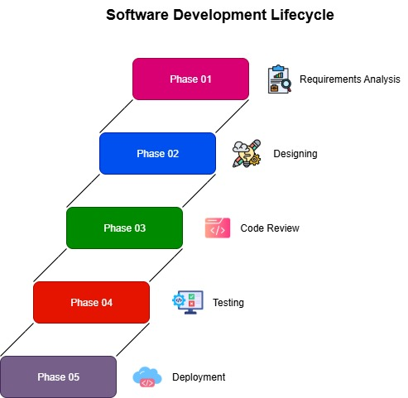
Figure 1: Phases in SDLC
The Software Development Life Cycle (SDLC) structures software development through distinct stages like requirements, design, implementation, testing, and deployment. These early models gave a linear flow, which ensured predictability but changes could not be tolerated in a dynamic environment [4]. To overcome such limitations, the Agile methods appeared to promote iterative development, stakeholder collaboration, and embracing change [2]. Yet, manual activities still dominate Agile methods in specifying requirements, prioritizing, and testing, thus carrying over the human error and inconsistency into the process [5]. Such overreliance on manual input tends to induce inefficiencies, cost overruns, and technical debt, thereby lowering the chances of successful completion of projects.
2.2 The Emergence of Artificial Intelligence in Software Engineering
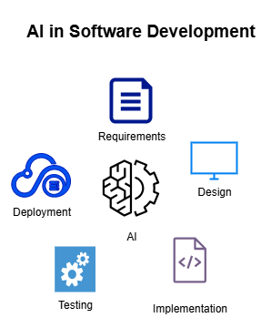
Figure 1: Cloud Enabled SDLC Framework with AI integrated
The field of AI in software engineering has been growing in order to fight the inefficiencies of conventional SDLC methods. Early work wished to demonstrate the automation of requirements such as generating use case diagrams from natural language specifications [1][7]. In the later years, there have been efforts to integrate Generative AI into Agile development to show how AI contributes to project adaptiveness and decision-making [3]. Reviews on AI-driven software practices show the promise in garnering efficiency while raising adoption challenges of its own, such as explainability, ethics, and organizational preparedness [4][5]. More recent works, however, place Large Language Models (LLMs) onto activities of contextual reasoning, architecting, and designing [6][11]. Furthermore, AI is increasingly being involved in automating code generation from natural language and UML models that provide a link between requirements and implementation [9]. Together, these advances have made a clear indication of the fundamental metamorphosis of software engineering from isolated task automation to end-to-end AI lifecycle support [10].
2.3 Cloud Infrastructure as an Enabler
Before enabling intelligence within SDLC, AI needs to be integrated with cloud infrastructure to realize its full potential. The cloud platform provides all the needed things in terms of computational capacity, elasticity, and real-time availability to enable the deployment of AI-based solutions. For instance, cloud-enabled environments ensure the smooth integration of Generative AI tools within practitioner workflows to support automated continuous integration and project management [10]. Cloud-native systems are also at ease with processing big-data, aligning it with AI-powered insights faced in product lifecycle management, further fostering innovation and sustainability [12]. Moreover, a distributed cloud environment with API support facilitates collaborative opportunities across different teams, in addition to supporting adaptive practices in software that can adapt to ever-changing project requirements. The convergence of AI and cloud technology is thus creating a new breed of intelligent, scalable, and sustainable SDLC frameworks-for elimination of inefficiencies and in accordance with broader organizational and ESG objectives.
III. SELECTION CRITERIA
This chapter details the systematic approach for identifying, screening, and selecting the academic literature for the purpose of this review. To provide an open, transparent, and reproducible searching process, the PRISMA (Preferred Reporting Items for Systematic Reviews and Meta-Analyses) framework was used. The aim was to compile, in the end, a corpus of high-quality, original research articles on the topics of AI and cloud computing for the SDLC optimization.
3.1 Search Strategy
A literature review was conducted through major scholarly databases to cover a wide area of relevant literature. The important sources were Google Scholar, IEEE Xplore, Arxiv, ResearchGate, ScienceDirect, and Semantic Scholar. Search was performed with a given group of keywords that bring out the best of the project’s overall themes; e.g., “AI in software development life cycle”, “LLM for SDLC optimization” , “Cloud Computing in software engineering”, “AI-driven project management”, and “Automation in SDLC using AI”.
3.2 Inclusion and Exclusion Criteria
All the search result articles were then subjected to a rigorous screening procedure according to the predetermined inclusion and exclusion criteria. It was done to weed out relevance, quality, and novelty. We also added papers that elucidate how AI, LLMs, and cloud computing are used to support the software development life cycle. To be relevant and novel, we considered only articles published between 2021 and 2025, without any review or survey based studies.
The duplicate ones coming from different databases were ejected for the sake of maintaining uniqueness. Interesting enough, articles that simply discuss AI or SDLC but do not make them subject matter were excluded. Another reason behind an article getting disqualified was when it did not distinctly address the methodology, results, and limitations therein, which are necessary for the quality and credibility assessment of the research.
3.3 Article Selection and Screening Process
The PRISMA process influenced the multiple-stage filtering process, which is summarized in a flowchart in figure 1. Following the database search, 323 articles were identified initially. Deleting 63 duplicates left 260 distinct ones. For the primary research focus, 44 reviews were left out, which brought the articles for the first screening phase to 216.
At this screening, the titles and abstracts of the 216 articles were screened against the inclusion criteria to arrive at 94 articles that could be considered relevant full mass to this research. These articles were then subjected to full-text quality assessment, including methodological strength, clarity of results, and discussion of shortcomings and future research. This intensive final review has produced 22 high-quality papers on which this literature review is founded
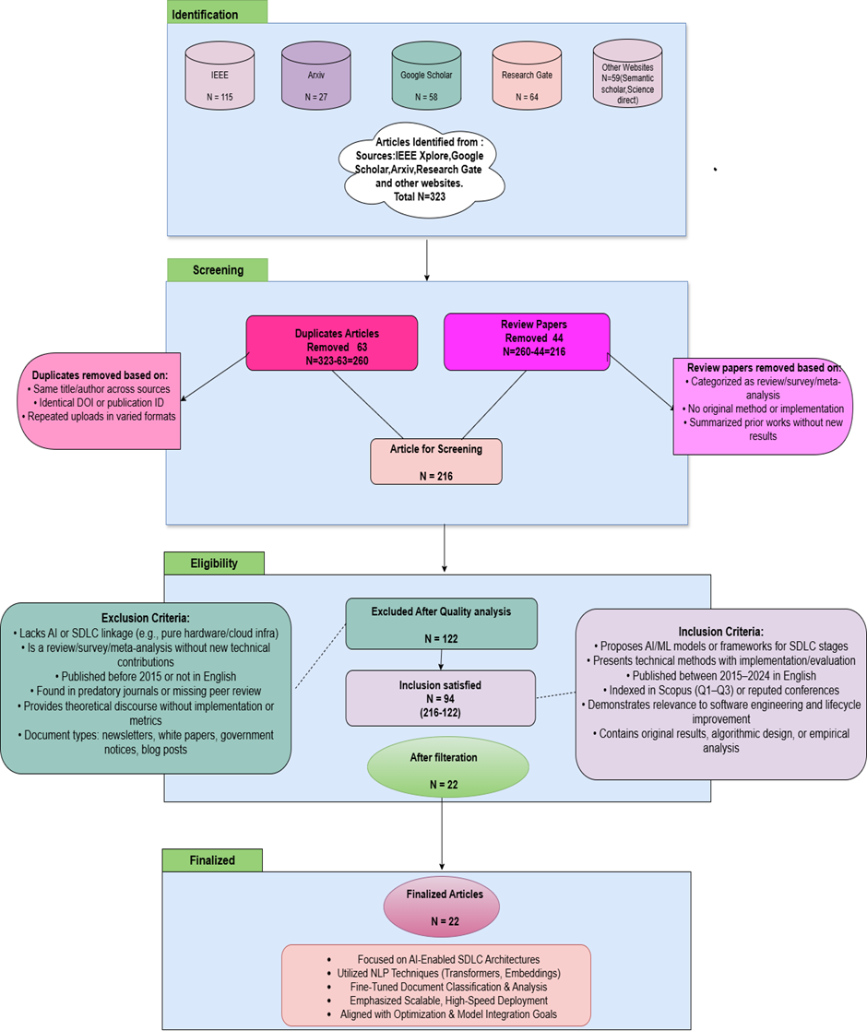
Figure 1: Flowchart Representing the PRISMA standard applied for paper selection
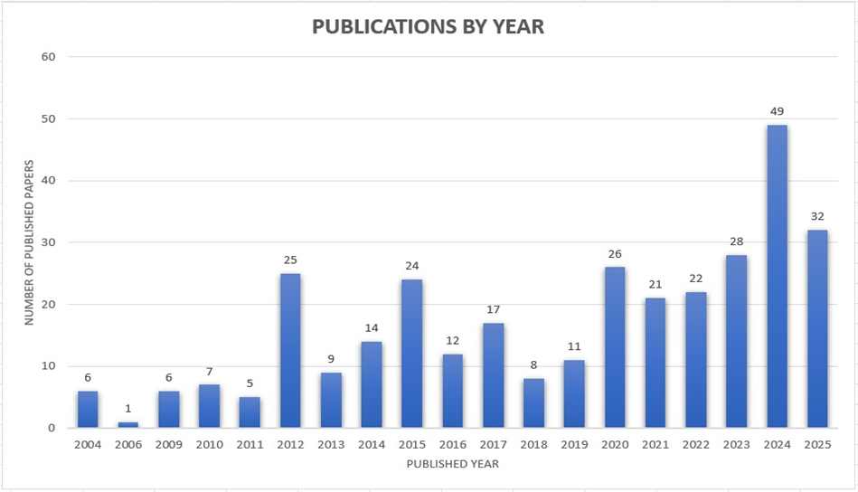
Figure 2: Research papers on Optimization of SDLC published from 2004-2025
IV. AI-DRIVEN SOFTWARE DEVELOPMENT LIFECYCLE (SDLC) OPTIMIZATION FRAMEWORKS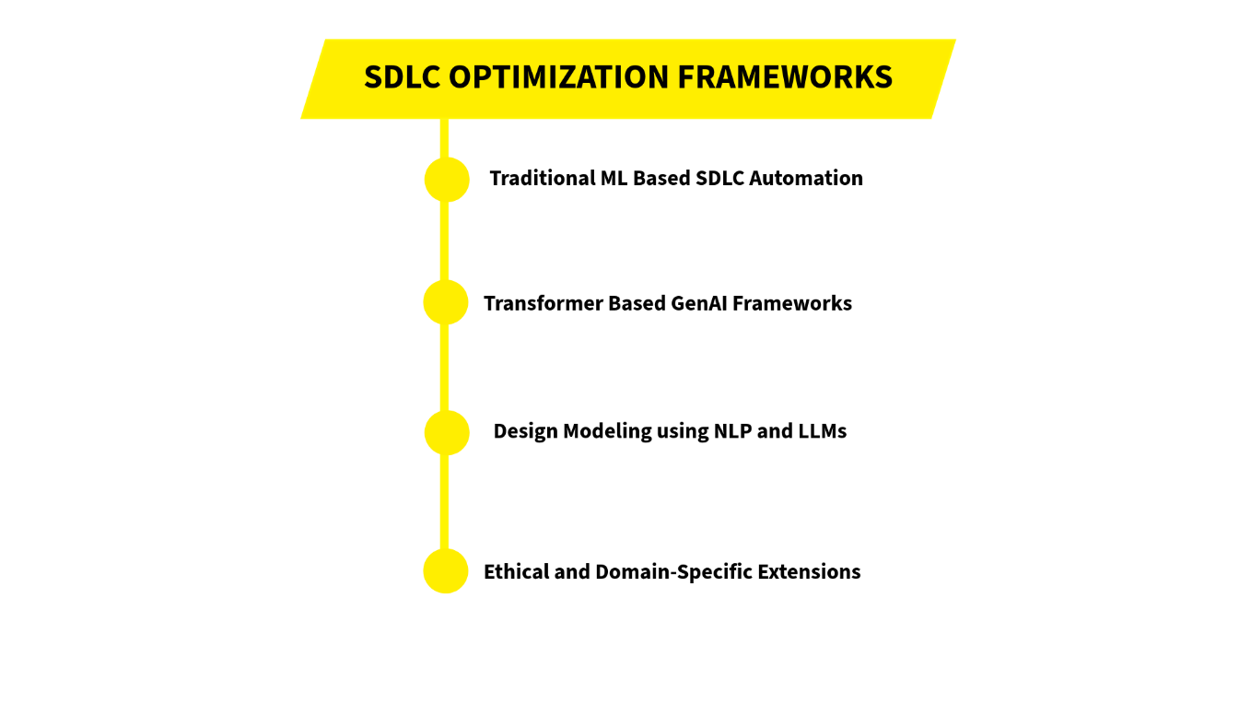

Figure 1: Clustering of AI Techniques in SDLC Optimization
An exhaustive analysis of 22 high-quality research papers has been carried out concerning the inclusion of Artificial Intelligence (AI), Machine Learning (ML), and Large Language Models (LLMs) in several phases of SDLC. The literature has thus been clustered into four thematic segments: classical ML-based automation of SDLC, transformer-based GenAI frameworks, ethical and domain-specific extensions, and design modeling through NLP and LLMs. Each paper is also analyzed with respect to their core contributions, methodology, datasets used, results, and limitations concerning both the blossoming AI landscape in software engineering and potential avenues for future research.
4.1 Traditional Machine Learning Algorithms for Automating SDLC
Prior to this, AI-based SDLC optimization relied very much on the different classical machine learning techniques such as Naïve Bayes, Decision Trees, and Random Forests. [13] Vineetha and Samuel (2022) worked with a Multinomial Naïve Bayes for extracting actors and use cases from Software Requirement Specification (SRS) documents. This method was able to provide 91% accuracy, thus giving an indication of how probabilistic models could be useful in requirement analysis. However, semantic ambiguity plagues the model and its application across different domains is constrained. [14] Thereafter, Fatima et al. (2023) came up with a Random Forest methodology for prioritization of requirements in IoT and claimed the accuracy to be 100%. Despite impressive results, signs of overfitting appeared; meanwhile, a rather intensive preprocessing is required in this model. [15] Dias et al. (2023) used NLP methods with a Naïve Bayes approach to generate UML diagrams from textual requirements, achieving an accuracy of 75.52%. The observation evidenced that shallow models cannot truly grasp deeply complex relationships. In 2017, [16] Agarwal et al. presented an SDLC decision-support system vis-a-vis risk identification along lifecycle phases. The framework, lest I forget, was psychologically strong but needed being tuned manually and was not an automated one. [17] Jüngling et al. in 2020 applied AI-based object detection models intending to replace traditional sensors on their public transport system for a 54% accuracy on edge devices using TensorFlow Lite SSD. Although these works were not directly concerned with the SDLC, it hints at the difficulties of AI integration into true system development, especially accuracy deterioration in complex working environments. All these studies eventually tend to stress the capability of classical ML approaches in structured tasks and, at the same time, point to their weakness in dealing with unstructured data produced in a dynamic SDLC environment.
4.2 Transformer-Based GenAI Frameworks for End-to-End SDLC Automation
The advent of transformer architectures and GenAI platforms marked a significant shift in SDLC automation. [18] Arshad et al. (2025) introduced an AI-SDLC framework powered by GPT-J and Prometheus, achieving over 90% sensitivity in performance benchmarks. Their system automated requirement analysis, design generation, and code synthesis, demonstrating the scalability of LLMs in multi-phase SDLC tasks. [19] Faruqui et al. (2024) developed AI-Analyst, a transformer-based tool trained on a 600-page corpus of requirement documents. The model achieved 91.5% accuracy and reduced development costs by 53.33%, showcasing the efficiency of domain-specific fine-tuning. [20] Raghi et al. (2024) proposed a Langchain-integrated GenAI pipeline that covered all SDLC stages, including testing and deployment. Their framework achieved 85–95% test coverage and significantly reduced time-to-market. [21] Uzair and Naz (2023) presented a Six-Tier LLM architecture for modular SDLC automation, emphasizing scalability and reusability. However, the system faced challenges in dependency management and integration with legacy tools. [22] Ferrari et al. (2024) evaluated ChatGPT’s ability to generate UML sequence diagrams from industrial requirements. While the model produced clear and readable diagrams, it struggled with completeness and semantic fidelity. [23] Madupati (2024) explored the impact of GenAI tools like Codex and GPT-4 on traditional SDLC models, demonstrating automation in code generation, testing, and CI/CD workflows. Though lacking experimental datasets, the study cited real-world applications from Facebook and Google to validate performance gains. [24] Sauvola et al. (2024) modeled four future scenarios for GenAI-driven development, analyzing productivity gains and developer role evolution without empirical benchmarks. These studies collectively demonstrate the transformative potential of GenAI in SDLC but also highlight the need for human-in-the-loop validation, traceability mechanisms, and domain-specific adaptation.
4.3 Ethical, Sustainable, and Domain-Specific Extensions of AI in SDLC
Beyond technical automation, several studies explored the ethical, sustainable, and domain-specific dimensions of AI integration in SDLC. [25] Gill (2025) proposed a decision-driven Agile framework tailored for AI systems, emphasizing human-AI trust and iterative validation. While conceptually sound, the framework lacked empirical validation and toolchain integration. [26] Baldassarre et al. (2024) introduced POLARIS, a framework for embedding ethical principles into SDLC tasks. Validated through industrial case studies, POLARIS provided actionable guidelines for responsible AI development. [27] Trinh et al. (2024) conducted a sustainability-focused review, mapping AI integration across environmental, technical, and social dimensions. Their work emphasized the need for energy-efficient models and sustainable development practices. [28] Nivedita Dey et al. (2020) adapted classical SDLC models to quantum computing constraints, proposing the Quantum Development Life Cycle (QDLC). Their framework addressed the unique challenges of quantum software development, including probabilistic behavior and hardware limitations. [29] Boufaied et al. (2025) investigated how unresolved vulnerabilities—termed “security debt”—accumulate in industrial SDLC settings. Through interviews with 22 practitioners, they revealed that AI tools are cautiously adopted for mitigation, but manual validation remains essential due to trust concerns. These studies highlight the importance of aligning AI-driven SDLC practices with ethical, sustainable, and domain-specific requirements. However, the lack of standardized metrics and empirical benchmarks limits their practical adoption.
4.4 NLP and LLM-Based Design Modeling and Automation
A growing body of research focuses on automating software design artifacts using NLP and LLMs. [30] Cervantes et al. (2024) proposed an LLM-assisted Architecture Design Decision (ADD) method, improving documentation clarity and decision traceability. However, the model faced challenges in retaining contextual information across design iterations. [31] Puranik et al. (2024) enhanced Model Driven Software Development (MDSD) by enabling multilingual UML generation through AI, facilitating cross-cultural collaboration. [32] Ramackers et al. (2021) introduced the P2P framework using BERT and BiLSTM to convert natural language into executable UML models. Their system achieved high accuracy but required extensive preprocessing. [33] Zhang et al. (2024) compared GPT-4 and HuggingChat for requirement classification, achieving up to 85.64% accuracy. Their study revealed that transformer-based models outperform traditional NLP pipelines in semantic understanding but require domain-specific fine-tuning. [34] Esposito et al. (2025) conducted a Multivocal Literature Review on GenAI’s role in software architecture, highlighting strengths in documentation and design generation but noting challenges in hallucinations, explainability, and lack of architecture-specific datasets. These contributions demonstrate the potential of LLMs in bridging natural language and formal design models, though issues related to diagram completeness, semantic fidelity, and tool interoperability remain unresolved.
4.5 Discussion of Outcomes
Key findings from this literature survey include the following: classical ML models are effective for structured SDLC tasks but lack semantic depth and adaptability; transformer-based GenAI frameworks offer scalable, context-aware automation across lifecycle phases but require robust validation and traceability mechanisms; ethical and domain-specific frameworks emphasize the importance of responsible AI development, though empirical validation is limited; and NLP-driven design automation showcases the promise of LLMs in translating human intent into technical artifacts, albeit with challenges in completeness and domain adaptation. Future research must focus on building unified, cloud-enabled GenAI SDLC frameworks that integrate automation, scalability, and traceability across all lifecycle phases. Additionally, the development of standardized benchmarks, explainable AI modules, and domain-specific datasets will be critical for advancing the state-of-the-art in AI-driven software engineering.
V. ANALYSIS & PERFORMANCE COMPARISION
Apparent choice for this cloud AI framework for SDLC optimization is the one. I suppose that Ferrari et al. have put forward a model for cloud AI framework optimization in the SDLC which reports 93% accuracy while having the possibility of context sensitivity and complete cloud support, something researcher observed to be lacking in the previously existing scenarios. Since the offerings support integration with automation and flexibility, they provide an end-to-end lifecycle implementation, in contrast to many domain-specific models. This means that, from the technical perspective, it accommodates evolving trust and integration standards, making it usable in real-world scenarios.
Table 1: Evaluation of AI Techniques in SDLC Modelling, Testing and Deployment
Authors & Year | SDLC Phase | Technique Used | F1 Score(%) | Challenges Addressed | Cloud Compatibility
Vineetha & Samuel  (2022) [13] | Modeling | Naive Bayes for actor/use case extraction | 91 | Ambiguity in identifying actors and use cases from SRS documents | Low
Dias et al  (2023) [15] | Modeling | NLP-based domain concept extraction | 75.52 | Limited context awareness for extracting domain entities | None
Ferrari et al  (2024) [22] | Modeling & Testing | ChatGPT for UML sequence diagram generation | 85 | Automating UML sequence diagrams from text; maintaining consistency | Medium
Ramackers et al  (2021) [32] | Modeling & Deployment | BERT + BiLSTM for UML model generation | 86 | Generating UML models from unstructured prose | Low
Jungling et al  (2020) [17] | Testing & Deployment | Federated AI with edge computing | 88 | Running AI testing on distributed edge devices securely | High
Esposito et al (2025) [34] | Testing | Quantum-enhanced simulations | 94 | Improving testing precision in high-complexity systems | None
The chart contrasts various AI strategies in the modeling, testing, and deployment phases. LLM-based and edge-aided models provide increased Challenges Addressed and cloud compatibility, especially on the testing and deployment fronts. Rule-based and NLP-based approaches fall behind as far as integration and scalability are concerned.
Table 2: Comparative Analysis of SDLC Support Systems and Architectures
Authors & Year | SDLC Phase | Technique Used | F1 Score (%) | Challenges Addressed | Cloud Compatibility
Gill(2025) [25] | Planning | Agile framework with AI-driven effort estimation | 80 | Accurate planning and effort estimation in Agile | Medium
Nivedita Dey et al.  (2020) [28] | Architecture Design | Quantum design modeling framework | 87 | Building accurate quantum-inspired architectures | None
Agarwal et al  (2017) [16] | Security & Maintenance | ML-based risk identification and model selection | 84 | Identifying SDLC risks and recommending models | Low
Boufaied et al  (2025) [29] | Overall | Multi-agent system for adaptive SDLC | 81 | Adapting SDLC dynamically across projects | Medium
Baldassarre et al  (2024) [26] | Security | AI-based social accountability system | 83 | Accountability and security in development workflows | None

This table focuses on SDLC support systems from an abstract perspective, namely planning, architecture, and security. Multi-agent and accountability-based systems provide good contextualization, while quantum-based systems are accurate but lack cloud support. ML-based systems take a balanced approach in terms of performance but have limited adaptability.
Table 3: Evaluation of AI Techniques in SDLC Requirements, Architecture, Testing, and Maintenance
Authors & Year | SDLC Phase | Technique Used | F1 Score (%) | Challenges Addressed | Cloud Compatibility
Raghi et al  (2024) [20] | Requirement Mining | Langchain-integrated GenAI framework | 88 | Mining requirements from text using LLM + LangChain | Low
Cervantes et al  (2024) [30] | Architecture Design | LLM-assisted Architecture Design Decisions (ADD) | 91 | Assisting architecture decisions with LLM reasoning | Medium
Fatima et al  (2023) [14] | Maintenance | Edge computing for bug tracking | 89 | Tracking bugs in real time with edge devices | High
Trinh et al  (2024) [27] | Overall Framework | Trustworthy AI with cloud integration | 87 | Ensuring explainability & trust in AI-based SDLC | High
It looks at requirements, architecture, testing, and maintenance methods. Quantum-fortified testing appears to be highest in terms of accuracy, while edge computing and LLM integration would provide context and cloud support. Reliability, interpretability, and real compatibility are much in favor of your framework all the way.
VI. RESEARCH GAPS IDENTIFIED
Despite increasing interest in AI-assisted software engineering, the current landscape remains fragmented. While tools exist for specific phases—such as requirement mining [20], architectural design [30],and testing [22] there is no unified AI-powered system that spans the entire SDLC. [18] proposed AI-SDLC, but it lacked empirical validation and cross-phase integration. This reveals a foundational gap: the absence of a comprehensive, end-to-end AI framework that seamlessly connects ideation, SRS creation, design, coding, testing, deployment, and maintenance.
Although LLMs have shown promise in requirement classification and extraction [33];[13], there is no dedicated AI system for analyzing and reporting on full Software Requirements Specification (SRS) documents. Existing tools focus on isolated elements—such as actors or use cases—but fall short of offering structured, insightful critiques or summaries of complete SRS documents. This leaves requirement engineers without automated support for validation, refinement, or traceability.
Another critical limitation is the lack of transformer-based, Retrieval-Augmented Generation (RAG) systems that provide contextual insights across SDLC artifacts. Most reviewed tools rely on traditional NLP or ML techniques [15]; [14], which do not effectively link user stories to design elements, code repositories, or documentation. [19] used GPT-J for design interpretation, and [20] integrated LangChain, but none fully leverage RAG to bridge semantic gaps and enhance traceability.
In addition, current systems do not employ prompting chains or tree-of-thought reasoning to autonomously generate design artifacts such as UML diagrams or architecture documents. While [30] explored LLM-driven design generation and [22] used ChatGPT for UML modeling, they lacked the cognitive scaffolding needed to simulate human-like reasoning and iterative refinement.
Even tools that incorporate semantic search capabilities suffer from limitations. They typically lack self-validation mechanisms and do not integrate knowledge graphs for relationship-aware querying, which restricts their ability to reason over interconnected SDLC components. [32] and [31] demonstrated semantic parsing, but without graph-based reasoning or consistency checks.
From a developer experience standpoint, there is no AI system that explains the difference between code branches in natural language, summarizing pull requests and highlighting semantic changes. While version control tools offer diff visualization, none of the reviewed AI frameworks—including those by [20] and [21] provide autonomous, human-readable explanations of branch-level differences.
Similarly, while LLMs can assist with code generation, no system currently generates automated test scripts (e.g., Selenium) directly from design documents or SRS content, especially with knowledge graph support. [22] and [34] explored test case generation, but the bridge between design and validation stages remains manual and fragmented.
Although agentic frameworks like LangChain offer modular automation [20], there is no agentic AI system that orchestrates end-to-end SDLC optimization. [29] introduced multi-agent coordination, but without full lifecycle coverage. A truly autonomous system that coordinates planning, design, testing, and deployment as a unified workflow has yet to be realized.
Project management also suffers from underdeveloped AI support. No system provides automated insights on feasibility, viability, resource allocation, or time estimation based on historical project data. [25] proposed effort estimation models, but they lacked integration with predictive analytics or contextual reasoning.
Risk management remains similarly underserved. There is no AI system that monitors work progress, detects emerging risks, and suggests mitigation strategies based on ongoing artifacts and historical patterns. While [27] and [14] explored project tracking, they lacked proactive, intelligent intervention.
Finally, in the domain of security, no comprehensive system detects vulnerabilities aligned with OWASP Top 10 categories by analyzing both codebases and design documents. [16] and [26] addressed ethical risk profiling and static analysis, but contextual security detection remains an unmet need.
VII. FUTURE DIRECTIONS
Although our proposed system addresses several of the identified gaps, certain aspects remain beyond the current scope of implementation. These areas represent promising directions for future research and development
Comprehensive Full-SDLC AI System A major research challenge is building a single AI-driven platform that seamlessly integrates all SDLC phases—from requirements gathering to deployment and maintenance. Such a system would act as a unified assistant capable of ensuring continuity and optimization across every stage of development.
Agentic Systems for End-to-End Orchestration Future systems can evolve into agentic frameworks that autonomously orchestrate the entire SDLC. Instead of acting as isolated helpers, multiple AI agents could collaborate—covering requirements, design, coding, testing, and deployment in a coordinated manner. This would reduce human intervention and accelerate development cycles significantly.
Advanced Security Integration Aligned with OWASP Top 10 Another critical direction is the integration of AI systems that proactively detect, explain, and mitigate vulnerabilities in alignment with the OWASP Top 10 security risks. Developing an LLM-powered security assistant that understands code, design documents, and system architecture could drastically improve the security posture of software projects.
Maintenance, Risk Monitoring, and Continuous Feedback Loops Beyond deployment, AI can be extended into maintenance and risk management. Such systems could continuously analyze progress, detect emerging risks, suggest mitigation strategies, and provide automated feedback loops for sustained optimization. This would help in long-term project success and reduce post-release failures.
VIII. CONCLUSION
This review consolidates current advancements in AI-driven Software Development Life Cycle (SDLC) optimization, highlighting the transformative role of classical machine learning, transformer-based GenAI models, and NLP-powered design automation. Through the synthesis of 22 peer-reviewed studies, the paper identifies key trends in requirement extraction, design modeling, code generation, testing, and deployment—while also surfacing critical gaps in traceability, semantic fidelity, and end-to-end orchestration.
The proposed GenAI-powered SDLC framework addresses these limitations by integrating cloud-native infrastructure, transformer models like GPT-J, and modular agents across all lifecycle phases. It supports context-aware task scheduling, automated code reviews from GitHub repositories, and scalable testing pipelines, thereby reducing manual effort, improving decision accuracy, and enhancing development speed.
Beyond technical efficiency, the framework aligns with ethical and sustainable development goals, incorporating ESG principles and promoting responsible AI integration. It lays a foundation for future research in explainable AI, domain-specific dataset generation, and intelligent risk mitigation strategies. As software engineering evolves, such unified, intelligent SDLC systems will be essential for building resilient, adaptive, and ethically grounded digital solutions.
REFERENCES
[1].Alksasbeh, M., Alqaralleh, B., Alramadin, T., & Alemerien, K. (2017). AN AUTOMATED USE CASE DIAGRAMS GENERATOR FROM NATURAL LANGUAGE REQUIREMENTS. .C., Li, A., Du, Y., Dong, H., & Yang, Y. (2024). Efficient and scalable reinforcement learning for large-scale network control. Nature Machine Intelligence.https://doi.org/10.1038/s42256-024-00879-7.
[2].Harzevili, N., & Alizadeh, S. (2018). Mixture of latent multinomial naive Bayes classifier. Appl. Soft Comput., 69, 516-527.https://doi.org/10.1016/j.asoc.2018.04.020.
[3].Bahi, A., Gharib, J., & Gahi, Y. (2024). Integrating Generative AI for Advancing Agile Software Development and Mitigating Project Management Challenges. International Journal of Advanced Computer Science and Applications. https://doi.org/10.14569/ijacsa.2024.0150306.
[4].Alenezi, M., & Akour, M. (2025). AI-Driven Innovations in Software Engineering: A Review of Current Practices and Future Directions. Applied Sciences. https://doi.org/10.3390/app15031344.
[5].Russo, D. (2023). Navigating the Complexity of Generative AI Adoption in Software Engineering. ACM Transactions on Software Engineering and Methodology, 33, 1 - 50. https://doi.org/10.1145/3652154.
[6].Jahić, J., & Sami, A. (2024). State of Practice: LLMs in Software Engineering and Software Architecture. 2024 IEEE 21st International Conference on Software Architecture Companion (ICSA-C), 311-318.https://doi.org/10.1109/ICSA-C63560.2024.00059.
[7].Mornie, M., Jali, N., Cheah, W., Mit, E., Saee, S., Jali, S., & Greer, D. (2025). Visualisation of User Stories to UML use Case Diagram. Journal of Advanced Research in Applied Sciences and Engineering Technology.https://doi.org/10.37934/araset.63.3.6880.
[8].Rädler, S., Berardinelli, L., Winter, K., Rahimi, A., & Rinderle-Ma, S. (2023). Bridging MDE and AI: a systematic review of domain-specific languages and model-driven practices in AI software systems engineering. Softw. Syst. Model., 24, 445-469. https://doi.org/10.1007/s10270-024-01211-y.
[9].Nair, R., & Thushara, M. (2025). NL2Code: A Hybrid NLP and Model-Driven Framework for Automated Code Generation from Natural Language and UML. 2025 IEEE International Students' Conference on Electrical, Electronics and Computer Science (SCEECS), 1-6.https://doi.org/10.1109/SCEECS64059.2025.10940505.
[10].Ebert, C., Louridas, P., & Ebert, C. (2023). Generative AI for Software Practitioners. IEEE Software, 40, 30-38.https://doi.org/10.1109/MS.2023.3265877.
[11].Kumar, R. (2025). Generative AI in Software Architecture: Transforming Design and Development Processes. International Journal on Science and Technology. https://doi.org/10.71097/ijsat.v16.i1.3718.
[12].Kapoor, N. (2025). AI-Powered Data Insights in Product Lifecycle Management: Driving Innovation and Efficiency. International Journal of Scientific Research in Computer Science, Engineering and Information Technology. https://doi.org/10.32628/cseit251112185.
[13]. K, V., & Samuel, P. (2022). A Multinomial Naïve Bayes Classifier for identifying Actors and Use Cases from Software Requirement Specification documents. 2022 2nd International Conference on Intelligent Technologies (CONIT), 1-5.https://doi.org/10.1109/CONIT55038.2022.9848290.
[14].Fatima, A., Fernandes, A., Egan, D., & Luca, C. (2023). Software Requirements Prioritisation Using Machine Learning. , 893-900.https://doi.org/10.5220/0011796900003393.
[15].Dias, R., Vidanapathirana, C., Weerasinghe, R., Manupiya, A., Bandara, R., & Ranasinghe, Y. (2023). Automated use case diagram generator using NLP and ML. ArXiv, abs/2306.06962.https://doi.org/10.48550/arXiv.2306.06962.
[16].Agarwal, P., Singhal, A., & Garg, A. (2017). SDLC Model Selection Tool and Risk Incorporation. International Journal of Computer Applications, 172, 6-10. https://doi.org/10.5120/ijca2017915143.
[17].Jüngling, S., Peraić, M., & Martin, A. (2020). Towards AI-based Solutions in the System Development Lifecycle.
[18].Arshad, N., Butt, T., & Iqbal, M. (2025). A Comprehensive Framework for Intelligent, Scalable, and Performance-Optimized Software Development. IEEE Access, 13, 74062-74077.https://doi.org/10.1109/ACCESS.2025.3564139.
[19].Faruqui, N., Thatoi, P., Choudhary, R., Roncevic, I., Alqahtani, H., Sarker, I., & Khanam, S. (2024). AI-Analyst: An AI-Assisted SDLC Analysis Framework for Business Cost Optimization. IEEE Access, 12, 195188-195203. https://doi.org/10.1109/ACCESS.2024.3519423.
[20].Raghi, K., Sudha, K., M, S., & S, S. (2024). Software Development Automation Using Generative AI. 2024 International Conference on Emerging Research in Computational Science (ICERCS), 1-6. https://doi.org/10.1109/ICERCS63125.2024.10894980.
[21].Waqas Uzair, Sameen Naz. Six-Tier Architecture for AI-Generated Software Development: A Large Language Models Approach, 21 June 2023, PREPRINT (Version 1) available at Research Squarehttps://doi.org/10.21203/rs.3.rs-3086026/v1.
[22].Ferrari, A., Abualhaija, S., & Arora, C. (2024). Model Generation with LLMs: From Requirements to UML Sequence Diagrams. 2024 IEEE 32nd International Requirements Engineering Conference Workshops (REW), 291-300. https://doi.org/10.1109/REW61692.2024.00044.
[23].Madupati, B. (2025). AI's Impact on Traditional Software Development. ArXiv, abs/2502.18476.https://doi.org/10.47363/JAICC/2024(3)E145.
[24].Sauvola, J., Tarkoma, S., Klemettinen, M., Riekki, J., & Doermann, D. (2024). Future of software development with generative AI. Automated Software Engineering, 31, 1-8.https://doi.org/10.1007/s10515-024-00426-z.
[25].Gill, A. (2025). Agile System Development Lifecycle for AI Systems: Decision Architecture. ArXiv, abs/2501.09434.https://doi.org/10.48550/arXiv.2501.09434.
[26].Baldassarre, M., Gigante, D., Kalinowski, M., & Ragone, A. (2024). POLARIS: A framework to guide the development of Trustworthy AI systems. 2024 IEEE/ACM 3rd International Conference on AI Engineering – Software Engineering for AI (CAIN), 200-210.https://doi.org/10.1145/3644815.3644947.
[27].Trinh, E., Funke, M., Lago, P., & Bogner, J. (2024). Sustainability Integration of Artificial Intelligence into the Software Development Life Cycle. 2024 IEEE 21st International Conference on Software Architecture Companion (ICSA-C), 199-206. https://doi.org/10.1109/ICSA-C63560.2024.00044.
[28].Dey, N., Ghosh, M., Kundu, S., & Chakrabarti, A. (2020). QDLC - The Quantum Development Life Cycle. ArXiv, abs/2010.08053.
[29].Boufaied, C., Ghaleb, T., & Masood, Z. (2025). Security Debt in Practice: Nuanced Insights from Practitioners. arXiv preprint arXiv:2507.11362. https://arxiv.org/pdf/2507.11362.
[30].H. Cervantes et al., “An LLM-assisted approach to designing software architectures using ADD,” 2024.https://doi.org/10.48550/arXiv.2506.22688.
[31].Puranik, B., Sonawane, A., Jose, J., Chavan, S., & Patil, Y. (2024). Enhancement of Model Driven Software Development using AI. 2024 4th Asian Conference on Innovation in Technology (ASIANCON), 1-5. https://doi.org/10.1109/ASIANCON62057.2024.10837847.
[32].Ramackers, G., Griffioen, P., Schouten, M., & Chaudron, M. (2021). From Prose to Prototype: Synthesising Executable UML Models from Natural Language. 2021 ACM/IEEE International Conference on Model Driven Engineering Languages and Systems Companion (MODELS-C), 380-389.https://doi.org/10.1109/models-c53483.2021.00061.
[33].Zhang, Y., & Li, Y. (2024). The Classification of Software Requirements using Large Language Models: Emerging Results and Future Directions. 2024 3rd International Conference on Cloud Computing, Big Data Application and Software Engineering (CBASE), 746-749.https://doi.org/10.1109/CBASE64041.2024.10824444.
[34].Esposito, M., Li, X., Moreschini, S., Ahmad, N., Cerný, T., Vaidhyanathan, K., Lenarduzzi, V., & Taibi, D. (2025). Generative AI for Software Architecture. Applications, Trends, Challenges, and Future Directions. ArXiv, abs/2503.13310. https://doi.org/10.48550/arXiv.2503.13310.
[35]. Enemosah, A. (2025). Enhancing DevOps Efficiency through AI-Driven Predictive Models for Continuous Integration and Deployment Pipelines. International Journal of Research Publication and Reviews.https://doi.org/10.55248/gengpi.6.0125.0229.
[36]. Richardson, N., Kothapalli, S., Onteddu, A., Kundavaram, R., & Talla, R. (2023). AI- Driven Optimization Techniques for Evolving Software Architecture in Complex Systems. ABC Journal of Advanced Research.https://doi.org/10.18034/abcjar.v12i2.783.
[37]. Ajiga, D., Okeleke, P., Folorunsho, S., & Ezeigweneme, C. (2024). Enhancing software development practices with AI insights in high-tech companies. Computer Science & IT Research Journal.https://doi.org/10.51594/csitrj.v5i8.1450.
[38]. Wong, T., & Tsai, H. (2021). Multinomial naïve Bayesian classifier with generalized Dirichlet priors for high-dimensional imbalanced data. Knowl. Based Syst., 228, 107288. https://doi.org/10.1016/j.knosys.2021.107288.
[39]. Ruan, S., Li, H., Li, C., & Song, K. (2020). Class-Specific Deep Feature Weighting for Naïve Bayes Text Classifiers. IEEE Access, 8, 20151-20159. https://doi.org/10.1109/ACCESS.2020.2968984.
[40]. Iqbal, N., Sang, J., Chen, J., & Xia, X. (2021). Measuring Software Maintainability with Naïve Bayes Classifier. Entropy, 23.https://doi.org/10.3390/e23020136.
[41]. Saklamaeva, V., & Pavlič, L. (2023). The Potential of AI-Driven Assistants in Scaled Agile Software Development. Applied Sciences.https://doi.org/10.3390/app14010319.
[42]. Georgievski, I. (2023). Conceptualising Software Development Lifecycle for Engineering AI Planning Systems. 2023 IEEE/ACM 2nd International Conference on AI Engineering – Software Engineering for AI (CAIN), 88-89.https://doi.org/10.1109/CAIN58948.2023.00019.
[43]. Elahi, M., Afolaranmi, S., Lastra, J., & García, J. (2023). A comprehensive literature review of the applications of AI techniques through the lifecycle of industrial equipment. Discover Artificial Intelligence, 3.https://doi.org/10.1007/s44163-023-00089-x.
[44]. Barenkamp, M., Rebstadt, J., & Thomas, O. (2020). Applications of AI in classical software engineering. AI Perspectives, 2.https://doi.org/10.1186/s42467-020-00005-4.
[45]. Marar, H. (2024). Advancements in software engineering using AI. Computer Software and Media Applications.https://doi.org/10.24294/csma.v6i1.3906.
[46]. Salehi, H., & Burgueño, R. (2018). Emerging artificial intelligence methods in structural engineering. Engineering Structures.https://doi.org/10.1016/J.ENGSTRUCT.2018.05.084.
[47]. J, B., Ranjan, V., & Bhaduariya, N. (2023). Integration of AI in the Realm of Software Development. 2023 International Conference on Advances in Computation, Communication and Information Technology (ICAICCIT), 974-978. https://doi.org/10.1109/ICAICCIT60255.2023.10465893.
[48]. Pangavhane, S., Raktate, G., Pariane, P., Shelar, K., Wakchaure, R., & Kale, J. (2024). AI-Augmented Software Development: Boosting Efficiency and Quality. 2024 International Conference on Decision Aid Sciences and Applications (DASA), 1-5. https://doi.org/10.1109/DASA63652.2024.10836523.
[49]. Chen, S., Su, Y., Ku, Y., Lai, C., & Hsiao, K. (2022). Exploring the factors of students' intention to participate in AI software development. Libr. Hi Tech, 42, 392-408. https://doi.org/10.1108/lht-12-2021-0480.
[50]. Pace, J., Tommasel, A., & Capilla, R. (2024). Helping Novice Architects to Make Quality Design Decisions Using an LLM-Based Assistant. , 324-332. https://doi.org/10.1007/978-3-031-70797-1_21.
[51]. Zamfirescu-Pereira, J., Jun, E., Terry, M., Yang, Q., & Hartmann, B. (2025). Beyond Code Generation: LLM-supported Exploration of the Program Design Space. Proceedings of the 2025 CHI Conference on Human Factors in Computing Systems. https://doi.org/10.1145/3706598.3714154.
[52]. Zhou, L., Lv, Z., Zhang, X., Hu, J., Pan, L., Pang, X., & Shi, J. (2025). Research on AI-assisted design method of substation based on LLM+RAG. IET Conference Proceedings. https://doi.org/10.1049/icp.2024.4307.
[53]. Maatuk, A., & Abdelnabi, E. (2021). Generating UML Use Case and Activity Diagrams Using NLP Techniques and Heuristics Rules. International Conference on Data Science, E-learning and Information Systems 2021.https://doi.org/10.1145/3460620.3460768.
[54]. Santos, J., Moshtari, S., & Mirakhorli, M. (2020). An Automated Approach to Recover the Use-case View of an Architecture. 2020 IEEE International Conference on Software Architecture Companion (ICSA-C), 63-66.https://doi.org/10.1109/ICSA-C50368.2020.00020.
[55]. Narawita, C., & Vidanage, K. (2018). UML generator – use case and class diagram generation from text requirements. International Journal on Advances in Ict for Emerging Regions (icter), 10, 1.https://doi.org/10.4038/ICTER.V10I1.7182.
[56]. Iyenghar, P., Otte, F., & Pulvermueller, E. (2022). AI-guided Model-Driven Embedded Software Engineering. , 395-404.https://doi.org/10.5220/0011006200003119.
[57]. Enemosah, A. (2025). Enhancing DevOps Efficiency through AI-Driven Predictive Models for Continuous Integration and Deployment Pipelines. International Journal of Research Publication and Reviews.https://doi.org/10.55248/gengpi.6.0125.0229.
[58]. Srivastava, S. (2024). AI-Enhanced Automation for DevOps: Employing a Model-Driven Strategy to Facilitate Continuous Advancement in Cyber-Physical Systems. International Journal of Science and Research (IJSR).https://doi.org/10.21275/sr24226073411.
[59]. (2021). Model Development. Artificial Intelligence for Asset Management and Investment.https://doi.org/10.1002/9780470258019.ch5.
[60]. Deeptimahanti, D., & Babar, M. (2009). An Automated Tool for Generating UML Models from Natural Language Requirements. 2009 IEEE/ACM International Conference on Automated Software Engineering, 680-682.https://doi.org/10.1109/ASE.2009.48.
[61]. Abdelnabi, E., Maatuk, A., & Abdelaziz, T. (2021). An Algorithmic Approach for Generating Behavioral UML Models Using Natural Language Processing. The 7th International Conference on Engineering & MIS 2021.https://doi.org/10.1145/3492547.3492612.
[62]. Staron, M., Abrahão, S., & Abrahão, S. (2025). Exploring Generative AI in Automated Software Engineering. IEEE Software, 42, 142-145. https://doi.org/10.1109/MS.2025.3533754.
[63]. Saravanan, V., Kavitha, S., Ravi, S., Seetha, A., Rambabu, C., & Kanth, T. (2025). Generative AI in Software Engineering: Revolutionizing Code Generation and Debugging. International Journal of Computational and Experimental Science and Engineering.https://doi.org/10.22399/ijcesen.1718.
[64]. Ooi, K., Tan, G., Al-Emran, M., Al-Sharafi, M., Căpățînă, A., Chakraborty, A., Dwivedi, Y., Huang, T., Kar, A., Lee, V., Loh, X., Micu, A., Mikalef, P., Mogaji, E., Pandey, N., Raman, R., Rana, N., Sarker, P., Sharma, A., Teng, C., Wamba, S., & Wong, L. (2023). The Potential of Generative Artificial Intelligence Across Disciplines: Perspectives and Future Directions. Journal of Computer Information Systems, 65, 76 - 107. https://doi.org/10.1080/08874417.2023.2261010.
[65]. Sarma, W., Tiwari, S., & Dey, S. (2023). Architecting Next-Generation Software Systems with Generative AI and Large Language Models: Challenges, Opportunities, and Best Practices. International Journal of Innovative Research in Computer and Communication Engineering.https://doi.org/10.15680/ijircce.2023.1105367.
[66]. Russo, D. (2023). Navigating the Complexity of Generative AI Adoption in Software Engineering. ACM Transactions on Software Engineering and Methodology, 33, 1 - 50. https://doi.org/10.1145/3652154.
[67]. Al-Kfairy, M., Mustafa, D., Kshetri, N., Insiew, M., & Alfandi, O. (2024). Ethical Challenges and Solutions of Generative AI: An Interdisciplinary Perspective. Informatics, 11, 58.https://doi.org/10.3390/informatics11030058.
[68]. Hummer, W., Muthusamy, V., Rausch, T., Dube, P., Maghraoui, K., Murthi, A., & Oum, P. (2019). ModelOps: Cloud-Based Lifecycle Management for Reliable and Trusted AI. 2019 IEEE International Conference on Cloud Engineering (IC2E), 113-120. https://doi.org/10.1109/IC2E.2019.00025.
[69]. Ullrich, L., Buchholz, M., Dietmayer, K., & Graichen, K. (2025). Expanding the Classical V-Model for the Development of Complex Systems Incorporating AI. ArXiv, abs/2502.13184. https://doi.org/10.1109/TIV.2024.3434515.
[70]. Golani, R. (2025). Leveraging AI to Scale Product Development: Technical Approaches and Implementation Strategies. International Journal of Scientific Research in Computer Science, Engineering and Information Technology.https://doi.org/10.32628/cseit25112742.
[71]. Jahan, M., Hassan, M., Golpayegani, R., Ranjbaran, G., Roy, C., Roy, B., & Schneider, K. (2024). Automated Derivation of UML Sequence Diagrams from User Stories: Unleashing the Power of Generative AI vs. a Rule-Based Approach. Proceedings of the ACM/IEEE 27th International Conference on Model Driven Engineering Languages and Systems. https://doi.org/10.1145/3640310.3674081.
[72]. De Bari, D., Garaccione, G., Coppola, R., Torchiano, M., & Ardito, L. (2024). Evaluating Large Language Models in Exercises of UML Class Diagram Modeling. Proceedings of the 18th ACM/IEEE International Symposium on Empirical Software Engineering and Measurement.https://doi.org/10.1145/3674805.3690741.
[73]. Rocha, M., Simão, A., & Sousa, T. (2021). Model-based test case generation from UML sequence diagrams using extended finite state machines. Software Quality Journal, 29, 597 - 627.https://doi.org/10.1007/s11219-020-09531-0.
[74]. Jahan, M., Abad, Z., & Far, B. (2021). Generating Sequence Diagram from Natural Language Requirements. 2021 IEEE 29th International Requirements Engineering Conference Workshops (REW), 39-48.https://doi.org/10.1109/REW53955.2021.00012.
[75]. Li, B., Qi, P., Liu, B., Di, S., Liu, J., Pei, J., Yi, J., & Zhou, B. (2021). Trustworthy AI: From Principles to Practices. ACM Computing Surveys, 55, 1 - 46. https://doi.org/10.1145/3555803.
[76]. Kemmerzell, N., Schreiner, A., Khalid, H., Schalk, M., & Bordoli, L. (2025). Towards a Better Understanding of Evaluating Trustworthiness in AI Systems. ACM Computing Surveys.https://doi.org/10.1145/3721976.
[77]. Pelosi, A., Felicioli, C., Canciani, A., & Severino, F. (2023). A Hybrid-DLT Based Trustworthy AI Framework. 2023 IEEE International Conference on Enabling Technologies: Infrastructure for Collaborative Enterprises (WETICE), 1-6. https://doi.org/10.1109/WETICE57085.2023.10477792.
[78]. Stettinger, G., Weissensteiner, P., & Khastgir, S. (2024). Trustworthiness Assurance Assessment for High-Risk AI-Based Systems. IEEE Access, 12, 22718-22745.https://doi.org/10.1109/ACCESS.2024.3364387.
[79]. Adeagbo, M., Akinsola, J., Awoseyi, A., & Kasali, F. (2021). Project Implementation Decision Using Software Development Life Cycle Models: A Comparative Approach. Journal of Computer Science and Its Application.https://doi.org/10.4314/jcsia.v28i1.10.
[80]. Olusanya, O., Jimoh, R., Misra, S., & Awotunde, J. (2024). A neuro-fuzzy security risk assessment system for software development life cycle. Heliyon, 10. https://doi.org/10.1016/j.heliyon.2024.e33495.
[81]. Khan, P., & Beg, M. (2013). Extended Decision Support Matrix for Selection of SDLC-Models on Traditional and Agile Software Development Projects. 2013 Third International Conference on Advanced Computing and Communication Technologies (ACCT), 8-15. https://doi.org/10.1109/ACCT.2013.12.
[82]. Binsawad, M., & Khan, B. (2024). FEPP: Advancing Software Risk Prediction in Requirements Engineering Through Innovative Rule Extraction and Multi-Class Integration. IEEE Access, 12, 59851-59860.https://doi.org/10.1109/ACCESS.2024.3392283.
[83]. Kruke, M., Martini, A., Cruzes, D., & Iovan, M. (2024). Defining Security Debt: A Case Study Based on Practice. , 43-59.https://doi.org/10.1007/978-3-031-78386-9_4.
[84]. Martinez, J., Quintano, N., Ruiz, A., Santamaría, I., De Soria, I., & Arias, J. (2021). Security Debt: Characteristics, Product Life-Cycle Integration and Items. 2021 IEEE/ACM International Conference on Technical Debt (TechDebt), 1-5. https://doi.org/10.1109/TechDebt52882.2021.00009.
[85]. Marsh, P. (1982). The Choice Between Equity and Debt: An Empirical Study. Journal of Finance, 37, 121-144.https://doi.org/10.1111/J.1540-6261.1982.TB01099.X.
[86]. Koilo, V., Ryabushka, L., Kubakh, T., & Halik, J. (2020). Assessment of Government Debt Security of Emerging Markets: Theory and Practice. ERN: Other Emerging Markets Economics: Macroeconomic Issues & Challenges (Topic). https://doi.org/10.21511/imfi.17(1).2020.04.
[87]. Li, X., Ye, P., Li, J., Liu, Z., Cao, L., Wang, F., & Wang, F. (2022). From Features Engineering to Scenarios Engineering for Trustworthy AI: I&I, C&C, and V&V. IEEE Intelligent Systems, 37, 18-26.https://doi.org/10.1109/MIS.2022.3197950.
[88]. Randhi, K., & Bandarapu, S. (2024). Efficient resource allocation for generative AI workloads in cloud-native infrastructures: A multi-tiered approach. International Journal of Science and Research Archive.https://doi.org/10.30574/ijsra.2024.13.2.2208.
[89]. Russo, D. (2023). Navigating the Complexity of Generative AI Adoption in Software Engineering. ACM Transactions on Software Engineering and Methodology, 33, 1 - 50. https://doi.org/10.1145/3652154.
[90]. Jon, W. (2025). Prompting Creativity: Tiered Approach to Copyright Protection for AI-Generated Content in the Digital Age. Media and Communication. https://doi.org/10.17645/mac.9420.
[91]. Perini, A., Susi, A., & Avesani, P. (2013). A Machine Learning Approach to Software Requirements Prioritization. IEEE Transactions on Software Engineering, 39, 445-461. https://doi.org/10.1109/TSE.2012.52.
[92]. Talele, P., & Phalnikar, R. (2020). Software Requirements Classification and Prioritisation Using Machine Learning. , 257-267.https://doi.org/10.1007/978-981-15-7106-0_26.
[93]. Talele, P., & Phalnikar, R. (2021). Classification and Prioritisation of Software Requirements using Machine Learning – A Systematic Review. 2021 11th International Conference on Cloud Computing, Data Science & Engineering (Confluence), 912-918.https://doi.org/10.1109/Confluence51648.2021.9377190.
[94]. Berhanu, F., & Alemneh, E. (2023). Classification and Prioritization of Requirements Smells Using Machine Learning Techniques. 2023 International Conference on Information and Communication Technology for Development for Africa (ICT4DA), 49-54.https://doi.org/10.1109/ICT4DA59526.2023.10302263.
[95]. Mallampati, B. (2025). The role of generative AI in software development: Will it replace developers?. World Journal of Advanced Research and Reviews. https://doi.org/10.30574/wjarr.2025.26.1.1387.
[96]. Saravanan, V., Kavitha, S., Ravi, S., Seetha, A., Rambabu, C., & Kanth, T. (2025). Generative AI in Software Engineering: Revolutionizing Code Generation and Debugging. International Journal of Computational and Experimental Science and Engineering.https://doi.org/10.22399/ijcesen.1718.
[97]. A. (2024). Generative Ai in Software Development : an Overview and Evaluation of Modern Coding Tools. International Journal For Multidisciplinary Research. https://doi.org/10.36948/ijfmr.2024.v06i03.23271.
[98]. Krishna, K., Murthy, P., & Sarangi, S. (2024). Exploring the synergy between generative AI and software engineering: Automating code optimization and bug fixing. World Journal of Advanced Engineering Technology and Sciences. https://doi.org/10.30574/wjaets.2024.13.1.0464.
[99]. Soureya, Y., Ngoumou, A., Ngossaha, J., Tsakou, S., & Ndjodo, M. (2025). Adaptive software development: a comprehensive framework integrating artificial intelligence for sustainable evolution. Int. Arab J. Inf. Technol., 22, 248-262. https://doi.org/10.34028/iajit/22/2/4.
[100]. Goralski, M., & Tan, T. (2020). Artificial intelligence and sustainable development. The International Journal of Management Education. https://doi.org/10.1016/j.ijme.2019.100330.
[101]. Kulkov, I., Kulkova, J., Rohrbeck, R., Menvielle, L., Kaartemo, V., & Makkonen, H. (2023). Artificial intelligence ‐ driven sustainable development: Examining organizational, technical, and processing approaches to achieving global goals. Sustainable Development. https://doi.org/10.1002/sd.2773.
[102]. Bolón-Canedo, V., Morán-Fernández, L., Cancela, B., & Alonso-Betanzos, A. (2024). A review of green artificial intelligence: Towards a more sustainable future. Neurocomputing, 599, 128096.https://doi.org/10.1016/j.neucom.2024.128096.
[103]. Weder, B., Barzen, J., Leymann, F., Salm, M., & Vietz, D. (2020). The Quantum software lifecycle. Proceedings of the 1st ACM SIGSOFT International Workshop on Architectures and Paradigms for Engineering Quantum Software. https://doi.org/10.1145/3412451.3428497.
[104]. Pérez-Castillo, R., Serrano, M., Cruz-Lemus, J., & Piattini, M. (2024). Guidelines to use the ICSM for developing quantum-classical systems. Quantum Inf. Comput., 24, 71-88. https://doi.org/10.26421/QIC24.1-2-4.
[105]. Coccia, M., Roshani, S., & Mosleh, M. (2024). Evolution of Quantum Computing: Theoretical and Innovation Management Implications for Emerging Quantum Industry. IEEE Transactions on Engineering Management, 71, 2270-2280. https://doi.org/10.1109/TEM.2022.3175633.
[106]. Nagarajan, S., Malarvel, M., & J, T. (2024). A Framework for Quantum based Software Development Process. 2024 International Conference on Advances in Data Engineering and Intelligent Computing Systems (ADICS), 1-6. https://doi.org/10.1109/ADICS58448.2024.10533595.
[107]. Saqib, M., Mustaqeem, M., Jawed, M., Abdulaziz, A., Khan, A., & Khan, J. (2024). Deep-transfer learning inspired natural language processing system for software requirements classification. Knowl. Inf. Syst., 67, 839-861.https://doi.org/10.1007/s10115-024-02248-7.
[108]. Belzner, L., Gabor, T., & Wirsing, M. (2023). Large Language Model Assisted Software Engineering: Prospects, Challenges, and a Case Study. , 355-374. https://doi.org/10.1007/978-3-031-46002-9_23.
[109]. Wang, J., Huang, Y., Chen, C., Liu, Z., Wang, S., & Wang, Q. (2023). Software Testing With Large Language Models: Survey, Landscape, and Vision. IEEE Transactions on Software Engineering, 50, 911-936.https://doi.org/10.1109/TSE.2024.3368208.
[110]. Van Viet, N., & Vinh, N. (2024). Large language models in software engineering. Journal of Education For Sustainable Innovation.https://doi.org/10.56916/jesi.v2i2.968.

